Spring IOC : project 1

**Create New Project :**

File 🡪New🡪Java Project🡪Give The Project Name🡪Finish

**Create Package:**

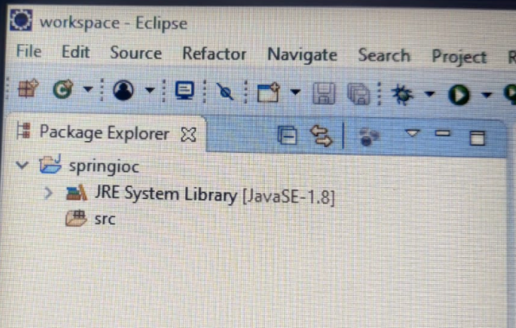

* Src(right click)🡪 New🡪 Class🡪 Give Package Name (com.jspiders.pkg) and Class Name

(Zomato) 🡪 Finish

* Src(right click)🡪 New🡪 Class 🡪 Class Name (User)🡪 Finish

**Create config.xml file:**

* Src(right click)🡪 New🡪Other🡪XML🡪XML file🡪Next🡪File Name (config.xml)🡪Finish
* 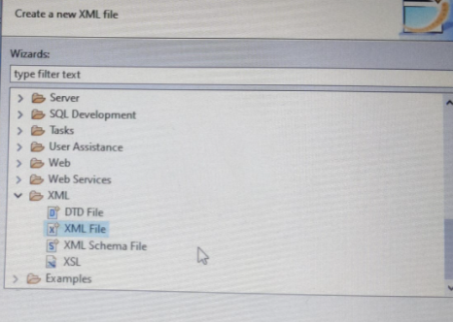

**Adding jars:**

<https://repo.spring.io/ui/native/release/org/springframework/spring/5.1.10.RELEASE>

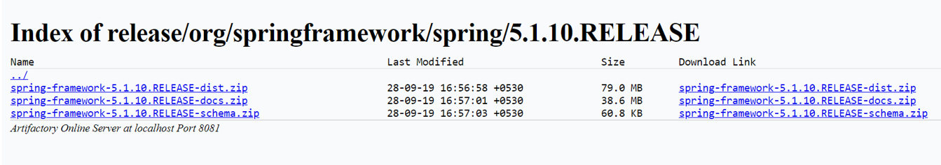

* Download first zip file and extract it (spring-framework-5.1.10.RELEASE-dist.zip)
* Project name(right click)🡪 build path🡪configure build path🡪 libraries🡪 add external jars🡪 go to the extracted file (spring-framework-5.1.10.RELEASE)🡪libs🡪select all files🡪open🡪apply and close

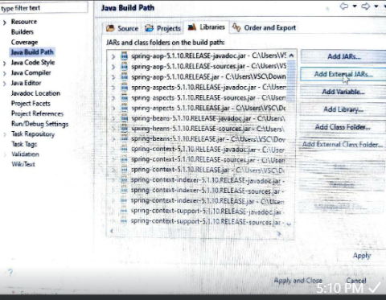

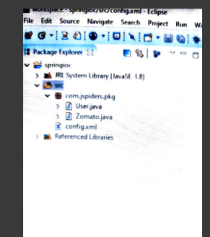

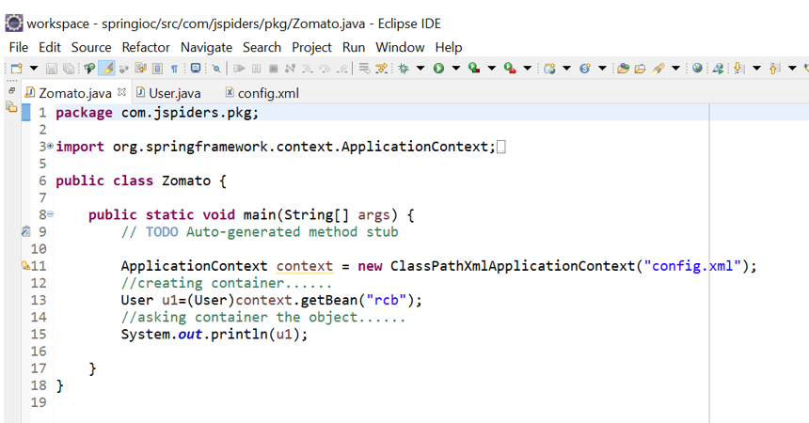

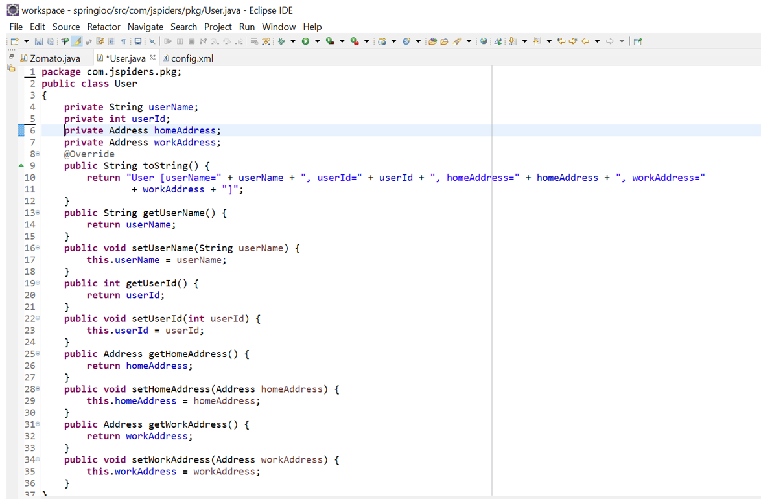

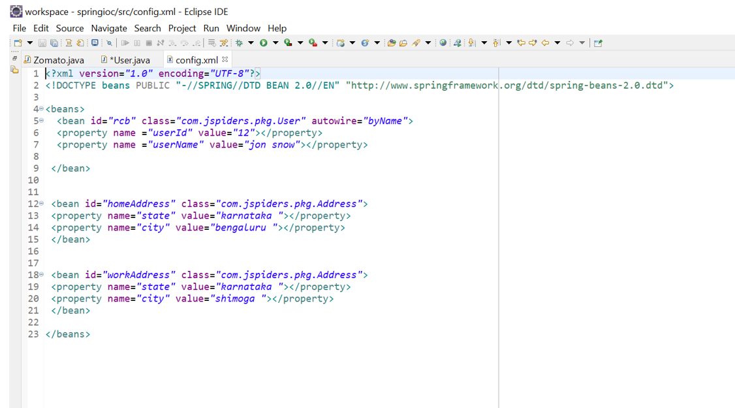

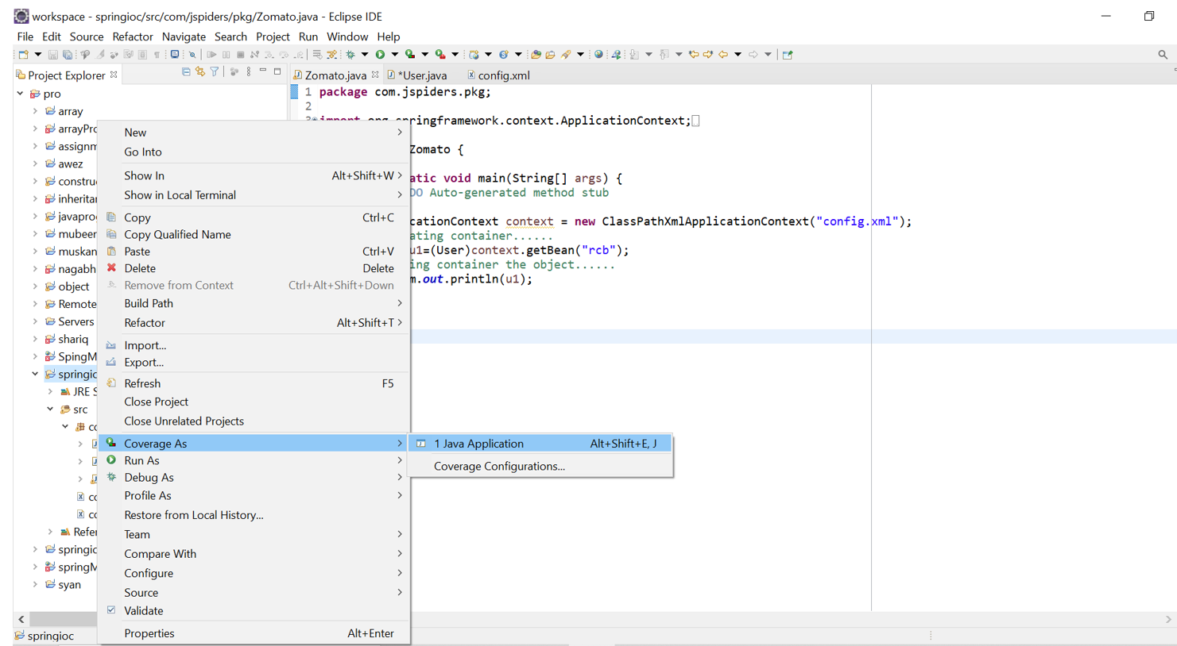

Output :

